Updated Jan. 18/2018 | February2018
Sunday | Monday | Tuesday | Wednesday | Thursday | Friday | Saturday
 |  |  |  | 1 | 2 | 3
Meals on Wheels Valentines 1:45pm
PAC Hot Lunch Day (pizza)
Girls B-ball

4 | 5 | 6 | 7 | 8 | 9 | 10
 | Gr. 6 Speech Finals this week | Boys B-ball  Gr. 6 Speech Finals this week  PAC Hot Lunch Day (sushi) | Gr. 6 Speech Finals this week | Girls B-ball  Gr. 6 Speech Finals this week  PAC Hot Lunch Day (hamburger) | Olympic Opening Ceremony  Gr. 6 Speech Finals this week
11 | 12 | 13 | 14 | 15 | 16 | 17
 | FAMILY DAY  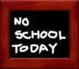 | Boys B-ball  PAC Hot Lunch Day(western)  Gr. 7 Speech Finals this week | Valentine’s Day  SPIRIT DAY: Valentine’s Day Surprise!  Gr. 7 Speech Finals this week | Flag Day: 1st bell @ flag  (wear uniforms if u have)  Gr. 7 Speech Finals this week  PAC Hot Lunch Day (hot dog)  Grade 6/7 Dance | Pro-D Day  (All Burnaby Schools)
18 | 19 | 20 | 21 | 22 | 23 | 24
 | PAC House Colours / Pink T-Shirt Sales Feb. 19th – 23rd | Boys Rec Playday  PAC Hot Lunch Day |  | Girls Rec Playday  PAC Hot Lunch Day (subway) | YPC – 10:45am (Intermediates)
25 | 26 | 27 | 28
 | Jump Rope for Heart “kick-off” Assembly  b4 recess or after lunch  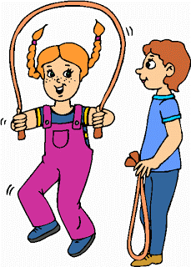 | Boys Comp Playday  PAC Hot Lunch Day(pasta) | Pink Shirt Day  C.O.L. Assembly  Olympic Closing Ceremony

