March | 2018
Sunday | Monday | Tuesday | Wednesday | Thursday | Friday | Saturday
 |  |  |  | 1 | 2 | 3
 |  |  |  | Girls Comp Playday | PAC Meeting 9:10am
4 | 5 | 6 | 7 | 8 | 9 | 10
11 | 12 | 13 | 14 | 15 | 16 | 17
Primary Days of Music this week |  |  |  | Battle of the Books kick-off | Jump Rope 4 Heart  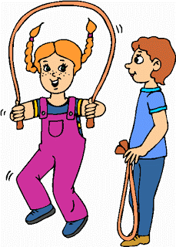
18 | 19 | 20 | 21 | 22 | 23 | 24
SPRING BREAK

25  SPRING BREAK | 26 | 27 | 28 | 29 | 30 | 31

