Name of School ____________Nelson Elementary School______________
Date of Visit _____________Wednesday, March 13th, 2019 @ 1:00pm____________
Visiting Team Members _____________Visiting trustee: Bill Brassington, Parm Hari___________
School Team Members Marilyn Kwok, Dianne Gauthier, Fatima Patel, Joycelyn Chan, Nancy Luo, Kalen Marquis

Response to Intervention
Intensive Interventions
Targeted Interventions
Universal Interventions

HIGHLIGHTS: What distinguishes your school? What are you proud of?
GENERAL SCHOOL INFORMATION:
- Our school population is approximately 356 students.
- We have a diverse community with a small number of low income families.
- 163 ELL students and 8 refugee students receive either pullout, Sheltered Instruction Observation Protocol (SIOP), or in-class support.
- The district’s Aboriginal resource teacher connects with our 11 Aboriginal students in their classrooms and collaborates with teachers to integrate Aboriginal content into all aspects of the curriculum. She works towards developing and supporting all student’s understanding of and appreciation for Aboriginal cultures, histories, and word views.
- We have 38 special needs children; 19 of these are low incidence children who require educational assistants to help them navigate their school days.
- We have 3 pending designations and require intensive support for either learning or behaviour challenges.
SCHOOL READING INITIATIVES:
- The Learning Support Teachers support struggling readers with:
  - in-depth assessment of reading development; PM Benchmark assessments, Observation Survey (RR)
  - a differentiated literacy reading program designed to meet each student’s individual needs
    - “Levelled Literacy” Intervention
    - “Reading Recovery” practices
    - “Fast ForWord”
    - “Reading Assistant”
- Primary Teachers
  - Common scheduled reading instruction times have been set up with ELL and LSS teachers to work collaboratively with Kindergarten, grade one and two teachers
  - Common literacy instruction/strategies and resources:
    - Guided Reading
    - Daily Five activities
    - Raz Kids
    - Literature Circles
    - Levelled Literacy Intervention (LLI)
    - LSS and K teacher co-teaching kindergartens reading
    - Organized and stocked our primary book room with resources
    - Cohort of staff who attended workshops around literacy
      - Communicating Student Learning
      - Assessment
- Intermediate Teachers:
  - Instruction times have been set up with LSS teachers to implement FFW and RA
  - Common literacy instruction/strategies and resources:
    - Adrienne Gear- Reading Powers
    - Faye Brownlie’s reading strategies,
    - literature circles
    - Battle of the Books
  - Cohort of staff who attended workshops around literacy
      - Communicating Student Learning
      - Assessment
- ELL Teachers support language learners with:
  - Reading A to Z program
  - Read Well
  - SIOP

- Literacy Committee
  - Birthday books
  - Summer program for struggling readers
  - Book Beast
  - Literacy Bingo
  - Reading in the Dark
  - Reading in House Colours
  - Drop Everything and Read
  - Reading at Secret Park
  - Buddy Reading
  - Teacher Swap Read Aloud???

SCHOOL SEL INITIATIVES:
We are in the process of developing this goal.
Counsellor supports:
- In-class instruction
- Developing common school wide strategies
- Developing classroom visuals for self-awareness
- Developing individual visuals for specific students
- Focusing on calm down strategies
Learning Support Services Teachers support:
- Developing individual visuals for specific students
- Focusing on calm down strategies
- Contingency maps
- Social stories

SCHOOL GOAL(S):

Goal 1: Our goal is to identify and improve reading levels for tier 2 students.

Goal 2: Our goal is to increase the number of students who are developing proficiency in self awareness.

Why was this goal(s) chosen?
Goal 1: This goal was chosen due to results of school wide reading assessment in conjunction with report card marks and reading diagnostic assessment. These results showed us that a number of students, in both primary and intermediate grades, were not meeting grade level expectations in reading. Many of the identified students have a history of struggling with reading. These students need targeted intervention to increase their skill set.
The school is working towards consistent common assessments and targeted instructional strategies as well as school-wide common strategies to make a difference in the reading achievement of all our students.
Goal 2: This goal was chosen due to the increased number of teacher requests for the office/counsellor/LSS personnel to deal with social-emotional and behavioural concerns.
What data/evidence supports your selection of this goal(s)?

Goal 1: Analysis of data obtained from a variety of Reading assessments: Year-End Reading Performance Standards Assessment Summary, Report Cards Assessment Summary, District Assessment of Reading Team (DART), Elementary Primary Reading Assessment (EPRA), Reading Proficiency Index, Reading Recovery Observation Survey, Levelled Literacy Ongoing Assessment, and PM Benchmarks.

Goal 2: Number of office referrals, teacher survey, and teacher/EA observations

Targeted Interventions
Universal Interventions
Intensive Interventions

What is in place to support all students?
Goal 1:
- Classroom teachers and learning support teachers administer DART and EPRA reading assessments twice a year.
- Building common practice and common language in reading for early primaries and will be working with intermediate teachers.
- Levelled Literacy Intervention (grade 1 and 2) and/ or Guided reading and Daily Five
- Community building literacy events and activities (ex. Family group activities).
- Library initiatives (ex: Book Beasts, Battle of the Books).
- Reading strategies, including Reading Power, Guided Reading, Reading 44, Daily Five, Literature Circles, etc., facilitated by teachers.
- Targeted reading instruction and strategies at student’s grade level and/or reading level.
- We have developed Nelson School Core Competencies with student focused “I can…” statements.
Goal 2:
- Whole School:
  - Story Circles & Class Meetings, Core Competencies, Positive Peaceful Purposeful Playground, Zones, MindUP, Incredible 5 Point Scale, PBS, hallway posters.
- Primary:
  - SEL Story Circle, Incredible 5 Point Scale, Zones of Regulation, calm down strategies
- Intermediate:
  - SEL Class Meetings, Incredible 5 Point Scale, Zones of Regulation, Juice Box Bully, Resilience (Super Powers, Super Kids), calm down strategies

How are you monitoring progress for all students? How frequently?
Each term:
-Report card marks
-Levelled Literacy benchmarking
-Global student tracking by administrator/school based team
-PM Benchmark assessments for vulnerable students (LSS)
Yearly:
-Year-End Performance Standards Assessment Summary for Reading Information
-Links to Literacy assessment for Kindergarten
Fall and Spring:
-Elementary Primary Reading Assessment (EPRA)
-District Assessment of Reading Team (DART)
-PM Benchmark assessments for all grade 1 students (school-wide)
Daily:
-Teacher observations and in-class assignments
-Collaboration and discussion among teachers
Goal 2:
-Teacher Observations/Survey once a year
-Student/staff connection survey once a year
How are you adjusting instruction/programming in response to student needs?
Goal 1:
- Regular school wide assessments in reading comprehension to identify student needs.
- ELL students receive either pullout, SIOP, or in-class support; use SIOP strategies including graphic organizers with ELL teachers and Teacher Librarians.
- Professional development initiatives.
- Intermediate teachers have requested collaborative meeting similar to previous bullet.

Goal 2:
- In-class instruction from Counsellor
- Classroom visuals for self-regulation across multiple settings (classroom, gym, common spaces, home) to normalize and to build capacity for peers as models and mentors
- Picture books and literature
- Customized visuals catered to individual students ie. contingency maps

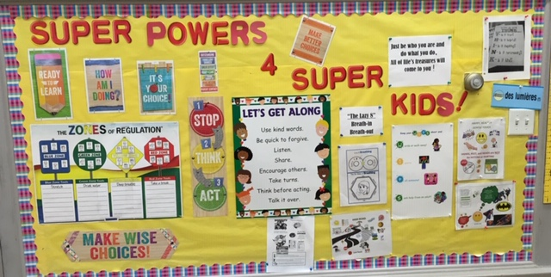

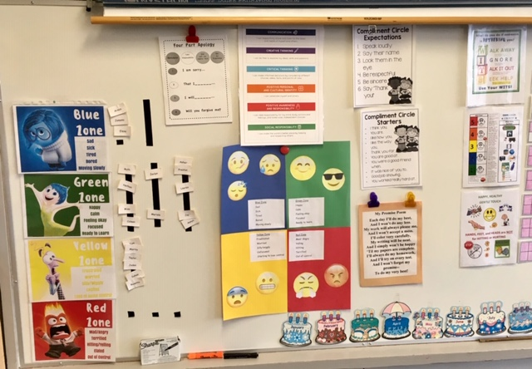

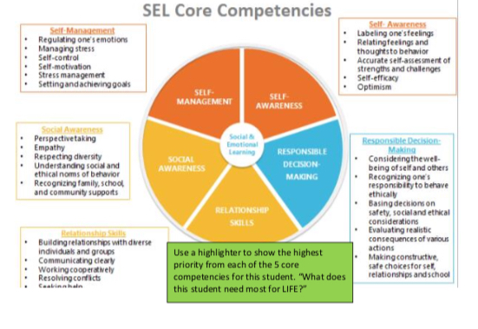

How is class-wide data informing your next steps?

Goal 1:
- Class-wide reading data is used to inform us of students who require additional support and identify the reading skills that need to be further taught
- Data also provided impetus for discussion around assessment, programming/resources, and to develop a common language and timetable

Goal 2:
- Student needs and teacher requests drive responsive engagement, teaching, re-teaching and rehearsal
- Data will provide us with a clear understanding of student’s needs and how to address next steps as well as verifying if proactive programs are working

Targeted Interventions
15 to 20%
Universal Interventions
Intensive Interventions

Based on class-wide assessment data, which students require more targeted interventions?
Goal 1:
- 24 students are emerging in reading fluency and comprehension expectations; this includes ELL students who have been identified with reading challenges beyond the acquisition of second language learning.
Goal 2:
-Students referred to the office multiple times
-Students referred for counselling
-Students who self-report a need for increased support with core competencies
(positive awareness and responsibility and social responsibility)
-Parent requests

What interventions are you implementing to support these students?

Goal 1:

For the purpose of the school review we have decided to focus on the tier two students who are receiving Fast ForWord (FFW), Reading Assistant and Leveled Literacy Intervention (LLI) Support.

FFW/Reading Assistant is a daily intervention where students take part in a research based computer intervention that works on the brain’s neurology to improve a child’s ability to read. Students are on individual programs for 30-40 minutes 5 days a week. Student’s work at their own pace and engage in activities to support word reading, sound recognition, following directions, English grammar, memory, comprehension, auditory processing, attention, vocabulary, fluency and sequencing.

LLI is a targeted Guided Reading program that is facilitated by a teacher to a small group of children. LLI focuses on phonics, vocabulary, writing, and reading problem solving strategies. Throughout the lessons, students are taught and monitored on their reading and reading problem solving abilities.

Goal 2: Counsellor working collaboratively with the classroom teacher in order to get to know struggling students in natural environment in order to create relationship so more explicit and personalized interventions can be established.

- Big & Little Buddies/Amazing Mentors
- Friendship & Fun
- Self-Esteem & Social Skills
- Conflict Resolution
- Playful pairs
- Problem solving/reflection sheets
- Contingency maps
- PBS
- Social Stories

How are you monitoring progress for these students? How frequently?

Fast ForWord:

Progress for students taking part in FFW is monitored on a daily basis. Students log onto the computer, complete their daily activities and look at a graph showing their results at the end of their daily session (data is shown below). Seeing daily data motivates students.
Levelled Literacy Intervention:

Progress monitoring for Students in LLI occurs every other lesson. Students are asked to read aloud a book they were taught in the previous lesson while the teacher listens to their reading. As the teacher listens to the reading, she records any reading errors and reading behaviours (how the child is solving words in their reading). At the end of the reading, the student is asked to summarize their reading and to answer both literal and inferential comprehension questions.

Goal 1:
For FFW/Reading Assistant, if a student is not making progress after several attempts (identified as a flat line on graph), then a FFW teacher provides direct intervention. The student is then monitored to ensure progress. Once a student has achieved 95% completion rate of their individual level, they are re-assessed and moved to the next level. If a student assesses at their grade level, then they graduate to Reading Assistant. After completing Reading Assistant, students will receive one-on-one support to generalize reading strategies they have been taught with the focus on inferencing. Interventions happen daily in FFW
For LLI, all students are currently progressing as instruction is geared to their reading level. If a child is struggling, a learning support teacher would provide further assessment (KTEA) to determine if there are any other factors impacting their learning and would consult with the psychologist. In consultation between the LLI facilitator and LSS teachers, considerations may be made to move the student to a different group.
School based team meetings occur weekly. Teachers fill out a questionnaire to assess students challenges and strengths; and the school based team then discusses the challenges, needs, and recommendations for next steps for the student.
LLI groups are fluid and constantly changing to meet student’s needs. Once assessment are complete students move to different groups based on the results of the assessment.
Goal 2:Consultations by classroom teacher
- Collaboration as a team (classroom teacher, parents, principal, ELL, LSS, counsellor, EA, district staff, outside agencies)
- Referrals to school based team

How is the data informing next steps?

Goal 1:

Data collected available to staff indicates if students require further intervention

Goal 2:
- Staff/parent communication of decreasing/increasing need
- Class reviews
- School based team
- Above interventions to be implemented based on needs
Targeted Interventions
Universal Interventions
Intensive Interventions
5 to 10%
Based on your Tier 2 assessment data, which students require more targeted interventions?
Goal 1:
- Students who have not responded to the Tier 2 level of intervention, or are not making the expected progress will move on to Tier 3.
- Students with Ministry Designations require targeted intervention as outlined in their IEPs.
- Students who have significant delays as indicated by the KTEA III Brief,but are waiting for further formal assessments with the school psychologist or a medical professional.
- Students who receive intensive explicit research-based individualized instruction. This involves one-on-one individual programming or small group specific to the student’s needs. Students are being supported by the following research based programs: Reading Recovery, Assistive Technology, visuals, PECs.
- Further testing/assessment are done for students not progressing.

Goal 2:
- Individual referrals to counselling
- H/R designated students
- Vulnerable students and families (refugees, kids in care, poverty)
- Students with safety plans and/or PBS plans which need to be revised
- Identified as working with outside agency

What individualized interventions are you implementing to support these students?

For the purposes of the school plan, we are tracking Reading Recovery data. Reading Recovery is a Tier three intervention for grade one students in reading. Reading Recovery teachers approach kindergarten teachers with regards to students who were struggling with reading in their kindergarten year. Kindergarten teachers use Links to Literacy assessments to identify each student’s reading skill. Once students have been identified by the classroom teacher, a Reading Recovery teacher administers the Reading Recovery Observation Survey and determines at what stanine each child is at. The stanines are a measure based on a Canadian national random sample (n=1000) collected in 2006-2007 from students across Canada. A student qualifies for Reading Recovery intervention when they have the lowest number of stanines. Each Reading Recovery teacher supports 2 children at a time for 30 minutes every day over 16-20 weeks.

INDIVIDUAL SCHOOL COUNSELLING & REFERRALS
- Individualized supports for identified students with school counsellor
- Cameray Child & Family Services, C&YMH assessment clinic, START emergency program; Big Brothers; Big Sisters, Go Girls!
- Collaboration with team and school staff

How are you monitoring progress for these students? How frequently?

Reading progress for Reading Recovery students occurs on a daily basis through a daily Running Record. A Running Record is a record of the student’s independent reading based on a book that the child was introduced to the previous day. During a running record students read aloud and the teacher records the words the student’s reading along with any errors, fluency, reading behaviors and sources of information the student uses to help them problem solve. Once the running record is over the teacher analyzes the record to inform his/her teaching and to determine the appropriate book level for the student.

PM Benchmark assessments 3 times a year.

Goal 2:
- Teacher/parent/outside agency communication and observations
- Data collection
- Student self-assessment

How are you adjusting instruction/programming in response to student needs?
Goal 1:
Daily lessons are created by the Reading Recovery teacher in response to the progress that the child is making and is catered to the specific needs of that particular child. Direct instruction that the teacher decides to focus on is informed by the student’s running record, the information the student is using to problem solve new text and by the student’s response to the direct instruction.
Adaptations for reading are addressed through school based team meetings.
Goal 2:
- Individualized programs and services based on needs (customized templates and processes)
- Continued reflection, research and consultations

