**Name of School** ____________Nelson Elementary School______________

**Date of Visit** ____________Nov 12, 2019_

**Visiting Team Members** _____________Jeanette Laursoo___________  
  
**School Team Members** Marilyn Kwok, Krishna Sharma, Fatima Patel, Joycelyn Chan, Nancy Luo, Kalen Marquis, Bryan Tesan

**Response to Intervention**

Intensive Interventions

Targeted Interventions

Universal Interventions

**HIGHLIGHTS: What distinguishes your school? What are you proud of?**

**GENERAL SCHOOL INFORMATION:**

* Our school population is approximately 363 students.
* We have a diverse community with a small number of low-income families.
* 165 ELL students and 1 refugee students receive either pullout, Sheltered Instruction Observation Protocol (SIOP), or in-class support.
* The district’s Aboriginal resource teacher connects with our 9 Aboriginal students in their classrooms and collaborates with teachers to integrate Aboriginal content into all aspects of the curriculum. She works towards developing and supporting all student’s understanding of and appreciation for Aboriginal cultures, histories, and word views.
* We have 39 special needs children; 22 of these are low incidence children who require educational assistants to help them navigate their school days.
* 36 students have counselling consent
* We have 3 pending designations and require intensive support for either learning or behaviour challenges.

**SCHOOL READING INITIATIVES:**

* The Learning Support Teachers support struggling readers with:
  + in-depth assessment of reading development: PM Benchmark assessments, Diebels
  + a differentiated literacy reading program designed to meet each student’s individual needs
    - Instruction times have been set up with LSS teacher to support students in class
    - “Levelled Literacy” Intervention
    - Primary Success
    - Jolly Phonics
* Primary Teachers
  + Common scheduled reading instruction times have been set up with ELL and LSS teachers to work collaboratively with Kindergarten, grade one and two teachers
  + Common literacy instruction/strategies and resources:
    - Guided Reading
    - Daily Five activities
    - Raz Kids
    - Literature Circles
    - Levelled Literacy Intervention (LLI)
    - LSS and K teacher co-teaching kindergartens reading
    - Organized and stocked our primary book room with resources
    - One to One Literacy
    - Cohort of staff who attended professional development workshops around literacy
      * Communicating Student Learning
      * Assessment
* Intermediate Teachers:
  + Common literacy instruction/strategies and resources:
    - Adrienne Gear- Reading Powers
    - Faye Brownlie’s reading strategies,
    - literature circles
    - Battle of the Books
  + Cohort of staff who attended workshops around literacy
    - * Communicating Student Learning
      * Assessment
* ELL Teachers support language learners with:
  + Reading A to Z program
  + Read Well
  + SIOP
  + LLI
* Literacy Committee
  + Birthday books
  + Summer program for struggling readers
  + Book Beast
  + Literacy Bingo
  + Reading in the Dark
  + Reading in House Colours
  + Drop Everything And Read(DEAR)- reading train in hallway
  + Reading at Secret Park
  + Buddy Reading
  + Teacher Swap Read Aloud
  + Staff favorite book public display in hallway
  + Me to We literacy event
  + April (poetry month) – writing poems with buddies/sharing at assembly

**SCHOOL SEL INITIATIVES:**

We are in the process of developing this goal.

Counsellor supports:

* In-class instruction
* Developing common school wide strategies
* Developing classroom visuals for self-regulation
* Developing individual visuals for specific students
* Focusing on calm down strategies

Learning Support Services Teachers and Counsellor support:

* Developing individual visuals for specific students
* Focusing on calm down strategies
* Contingency maps
* Social stories/Narrative Stories
* PBS
* Video Modelling
* Technology (iPads)
* Restorative problem solving

**SCHOOL GOAL(S):**

**Goal 1:** Our goal is to identify and improve reading levels for tier 2 students.

**Goal 2:** Our goal is to increase the number of students who are developing proficiency in self-regulation.

**Why was this goal(s) chosen?**

Goal 1: This goal was chosen due to results of school wide reading assessment in conjunction with report card marks and reading diagnostic assessment. These results showed us that some primary and intermediate students are “Emerging” in reading. Many of the identified students have a history of struggling with reading. These students need targeted intervention to increase their skill set.

The school is working towards consistent common assessments and targeted instructional strategies as well as school-wide common strategies to make a difference in the reading achievement of all our students.

Goal 2: This goal was chosen due to the increased number of teacher requests for the office/counsellor/LSS personnel to deal with social-emotional and behavioural concerns.

**What data/evidence supports your selection of this goal(s)?**

Goal 1: Analysis of data obtained from a variety of Reading assessments: Year-End Reading Performance Standards Assessment Summary, Report Cards Assessment Summary, District Assessment of Reading Team (DART), Elementary Primary Reading Assessment (EPRA), Reading Proficiency Index, Levelled Literacy Ongoing Assessment, and PM Benchmarks.

Goal 2: Number of office referrals, teacher survey, teacher/EA observations/data collection, UBC Climate Study with self-regulation component

Targeted Interventions

**Universal Interventions**

Intensive Interventions

**What is in place to support all students?**

Goal 1:

* Classroom teachers and learning support teachers administer DART and EPRA reading assessments twice a year.
* Building common practice and common language in reading for early primaries and will be working with intermediate teachers.
* Levelled Literacy Intervention (grade 1 and 2) and/ or Guided reading and Daily Five
* Community building literacy events and activities (ex. Family group activities).
* Library initiatives (ex: Book Beasts, Battle of the Books).
* Reading strategies, including Reading Power, Guided Reading, Reading 44, Daily Five, Literature Circles, etc., facilitated by teachers.
* Targeted reading instruction and strategies at student’s grade level and/or reading level.
* Nelson School Core Competencies with student focused “I can…” statements.

Goal 2:

* Whole School:
  + Story Circles & Class Meetings, Core Competencies, Positive Peaceful Purposeful Playground, Zones, MindUP, Incredible 5 Point Scale, PBS, WITS, hallway posters, Chill-Ville
* Primary:
  + SEL Story Circle, Incredible 5 Point Scale, Zones of Regulation, calm down strategies
* Intermediate:
  + SEL Class Meetings, Incredible 5 Point Scale, Zones of Regulation, Juice Box Bully, Resilience (Super Powers, Super Kids), calm down strategies

**How are you monitoring progress for all students? How frequently?**

**Each term:**  
-Report card marks  
-Levelled Literacy benchmarking   
-Global student tracking by administrator/school-based team  
-PM Benchmark assessments for vulnerable students (LSS)

*Sample of global student tracking:*



**Yearly:**  
-Year-End Performance Standards Assessment Summary for Reading Information  
-Links to Literacy assessment for Kindergarten

**Fall and Spring:**  
-Elementary Primary Reading Assessment (EPRA)  
-District Assessment of Reading Team (DART)  
-PM Benchmark assessments for all grade 1 students (school-wide)  
  
**Daily:**  
-Teacher observations and in-class assignments  
-Collaboration and discussion among teachers

Goal 2:   
-Teacher Observations/Survey twice a year  
-Student/staff connection survey twice a year

**How are you adjusting instruction/programming in response to student needs?**

Goal 1:

* Regular school wide assessments in reading comprehension to identify student needs.
* ELL students receive either pullout, SIOP, or in-class support; use SIOP strategies including graphic organizers with ELL teachers and Teacher Librarians.
* Professional development initiatives.

Goal 2:

* In-class instruction from Counsellor/LSST
* Classroom visuals for self-regulation across multiple settings (classroom, gym, common spaces, home) to normalize and to build capacity for peers as models and mentors
* Picture books and literature
* Customized visuals catered to individual students ie. contingency maps

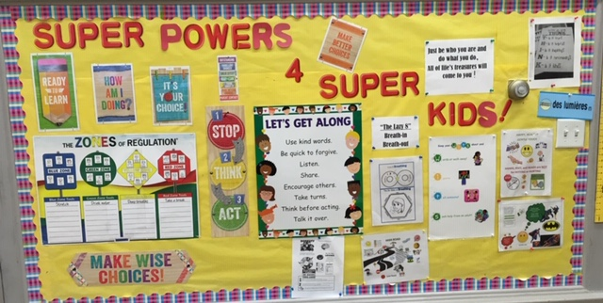

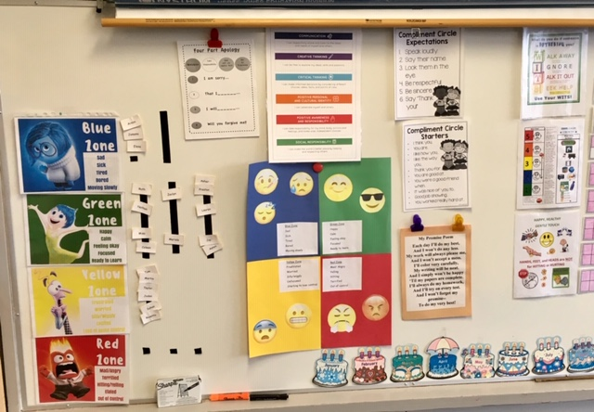

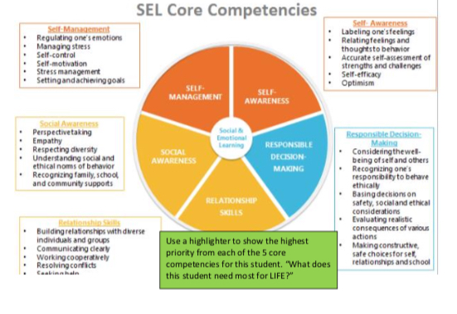

**How is class-wide data informing your next steps?**

**Goal 1:**

* Class-wide reading data is used to inform us of students who require additional support and identify the reading skills that need to be further taught
* Data also provided impetus for discussion around assessment, programming/resources, and to develop a common language and timetable

**Goal 2:**

* Student needs and teacher requests drive responsive engagement, teaching, re-teaching and rehearsal
* Data will provide us with a clear understanding of student’s needs and how to address next steps as well as verifying if proactive programs are working

**Targeted Interventions**

**15 to 20%**

Universal Interventions

Intensive Interventions

**Based on class-wide assessment data, which students require more targeted interventions?**

Goal 1:

- 5 intermediate students and 11 primary students are emerging in reading fluency and comprehension expectations; this includes ELL students who have been identified with reading challenges beyond the acquisition of second language learning.

Goal 2:  
-4 students will be tracked  
-Students referred to the office multiple times  
-Students referred for counselling  
-Students who self-report a need for increased support with core competencies   
(positive awareness and responsibility and social responsibility)  
-Parent requests

**What interventions are you implementing to support these students?**

Goal 1:

For the purpose of the school review we have decided to focus on the tier two students who are receiving Intermediate In-class support and Leveled Literacy Intervention (LLI) support.

LLI is a targeted Primary Guided Reading program that is facilitated by a teacher to a small group of children. LLI focuses on phonics, vocabulary, writing, and reading problem solving strategies. Throughout the lessons, students are taught and monitored on their reading and reading problem solving abilities.

In class support provides targeted intervention to allow students to participate in classroom reading activities with the support of the LSST. The LSST works collaboratively with the classroom teacher together.

Goal 2: Counsellor and Learning Support teachers working collaboratively with the classroom teacher in order to get to know struggling students in natural environment in order to create relationship so more explicit and personalized interventions can be established. Sometimes they might be working in a small group with the Counsellor or Learning Support teachers.

* Friendship & Fun
* Self-Esteem & Social Skills
* Conflict Resolution
* Playful pairs/games group
* Problem solving/reflection sheets
* Contingency maps
* PBS
* Social Stories/Narrative Stories

**How are you monitoring progress for these students? How frequently?**

**Levelled Literacy Intervention:**

Progress monitoring for students in LLI occurs every other lesson. Students are asked to read aloud a book they were taught in the previous lesson while the teacher listens to their reading. As the teacher listens to the reading, she records any reading errors and reading behaviours (how the child is solving words in their reading). At the end of the reading, the student is asked to summarize their reading and to answer both literal and inferential comprehension questions.

**In-class Support**

IPA or Intensive Phonological Awareness Program is an evidence base program that walks you through tier 2/3 instruction with explicit guidance, suggested scripts, teaching strategies and tips on what to do when a primary/intermediate student is still struggling with a skill.

Improves four critical phonological awareness skills, rhyming, initial sounds, final sounds, and complete segmenting and blending.

**GOAL #1 DATA:**

LLI - Primaries In-class Support - Intermediates

|  |  |  |
| --- | --- | --- |
| **NAME** | **2019** | **2020** |
| Student A | 0 |  |
| Student B | 0 |  |
| Student C | 0 |  |
| Student D | 0 |  |
| Student E | 0 |  |
| Student F | 8 |  |
| Student G | 8 |  |
| Student H | 8 |  |
| Student I | 8 |  |
| Student J | 12 |  |

|  |  |  |
| --- | --- | --- |
| **NAME** | **2019** | **2020** |
| Student K |  |  |
| Student L |  |  |
| Student M |  |  |
| Student N |  |  |
| Student O |  |  |

**GOAL #2 DATA**

|  |  |  |
| --- | --- | --- |
| **NAME** | **2019** | **2020** |
| Student P |  |  |
| Student Q |  |  |
| Student R |  |  |

**How are you adjusting instruction/programming in response to student needs?**

Goal 1:

For identified students struggling, a learning support teacher would provide further assessment (KTEA) to determine if there are any other factors impacting their learning and would consult with the psychologist.

School based team meetings occur regularly. Teachers fill out a questionnaire to assess students challenges and strengths; and the school-based team then discusses the challenges, needs, and recommendations for next steps for the students.

Goal 2:

* Consultations by classroom teacher
* Collaboration as a team (classroom teacher, parents, principal, ELL, LSS, counsellor, EA, district staff, outside agencies)
* Referrals to school-based team

**How is the data informing next steps?**

Goal 1:

* Look at reassessment to meet the students’ needs
* Look at making adaptations
* Consideration of changing groups or resources
* Consulting with parents, SBT, LSST, DLST and School Psychologist to consider further assessments and or interventions

Goal 2:

* Staff/parent communication of decreasing/increasing requests
* School based team
* Consulting with parents, Counsellor, SBT, LSST, DLST and School Psychologist to consider further assessments and or interventions

**SCHOOL TEAM VISIT SUMMARY REPORT**(to be completed by the Visiting Team)

**SCHOOL: ______________________________________ DATE: ______________**

**Promising Practices**



**Names of the Visiting Team Members**:

______________________________________ ____________________________________   
  
______________________________________ ____________________________________   
  
______________________________________ ____________________________________   
  
______________________________________ ____________________________________

**Recommendations**