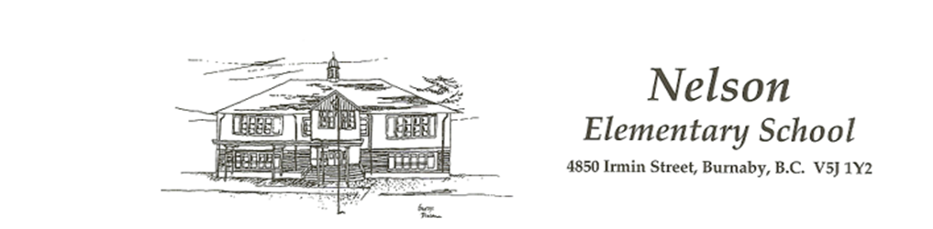

September 1st, 2020

Dear Nelson Elementary Parents and Guardians:

Welcome to another year at Nelson Elementary! We are looking forward to welcoming all students back and meeting our new students and families. For families in Kindergarten, you should have received an additional communication regarding gradual entry and “Welcome to Our School”. As a community of learners, we are committed to ensuring the health and safety of all our members. Our District is taking direction from Fraser Health Authority and are in regular contact with them, as well as the Ministries of Health and Education. As we prepare to welcome students back to our school in September, our priority is to maintain a healthy and safe environment for all.

Over the next week, we will be working to finalize your child’s classroom and learning group placement. More information regarding drop off and pick up procedures, as well as our staggered start and dismissal times, entrance protocols, and your child’s learning group will be communicated before your child’s orientation on either September 10th or 11th. As we diligently work to have our school ready for your child’s return, we would like to take this opportunity to share the following information.

Learning Groups
Upon returning to school your child will be placed in a learning group with age like peers to promote social interaction and learning. Your child’s learning group may encompass one or two classes, up to a maximum of 60 students and staff. Your child may occasionally interact with students and staff from other learning cohorts, but in this event the students will be expected to maintain their physical distance. Learning groups provide a range of benefits for students including:
Learning – allow full-time attendance in school
Social – increase peer interaction, avoid isolation
Emotional – increase peer support and connection
Psychological – decrease mental health impacts

Orientation Week
September 8-11 is our orientation week. On September 8 and 9, staff will be returning to school to complete preparations for a safe return to school for all children. Your child will be provided an orientation time (approximately 1 hour and 15 minutes) on either September 10th or 11th (Depending on the letter your last name starts with- see below). We have divided the school alphabetically and over grade to reduce the number of people on site during this transition and orientation. You may need to arrange for childcare options for those dates, as classes will only be in session for one hour.

Nelson Student Orientation

Sept. 10 | Sept. 11
Student Orientation  (in Classes/Learning Groups)  Family Last Names A-L  Grades 1-3  - Arrive at 9:00  - End at 10:15  Grade 4-5  - Arrive at 10:30  - End at 11:45  Grades 6-7  - Arrive at 1:00  - End at 2:15  Kindergarten 1:30 - 2:30  - Welcome to Our School Orientation | Student Orientation  (In Classes/Learning Groups)  Family Last Names M- Z  Grades 1-3  - Arrive at 9:00  - Ends at 10:15  Grade 4-5  - Arrive at 10:30  - Ends at 11:45  Grades 6-7  - Arrive at 1:00  - Ends at 2:15  Kindergarten 1:30 - 2:30  - Welcome to our School Orientation

Parent Survey Reminder
The Burnaby School District is requiring ALL parents to complete a return to school declaration of intent to indicate your plans for September. The survey is open until today, September 1 until 1:00pm. The link for the survey can be found on the District website.

Parent Information Meeting
We will be hosting a parent information meeting regarding our Nelson Elementary return to school plans on Thursday, Sept. 3rd at 3:00. This meeting will take place via Zoom. You will receive the access information by Wednesday, Sept. 2^{nd.} The meeting will be directed towards familiarizing parents with the systems we have in place at Nelson as well as what September will look like.

Health and Safety

The health and safety of our students and staff is our paramount concern as we return to school. Some important items to keep in mind:

We will be implementing twice daily cleaning of frequently touched surfaces throughout the building.

Regular handwashing/sanitizing routines will be established for all staff/students.

Parents and caregivers must assess their child daily for symptoms of illness before sending them to school and notify the school if they are remaining home.

Students who become ill, or exhibit symptoms throughout the day, will be isolated from others with parents being contacted to pick up their child.

To facilitate physical distancing, only essential staff and students will be allowed to enter the school.

All students will be provided with two masks, with students in grades 6-7 expected to wear them in common areas (ie. Hallways, etc)

All students bring their own supplies and refrain from sharing them with others.

Students are asked to bring their own food and are not permitted to share food in compliance with health and safety protocols.
- Students are encouraged to bring their own filled water bottle.

We hope this information provided is helpful to you in your family. We will provide you with further details as stated above by Wednesday, September 9. We look forward to welcoming your child back!

Sincerely,

Guy Hamilton

Principal
Nelson Elementary

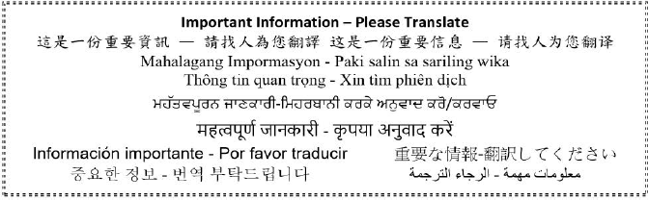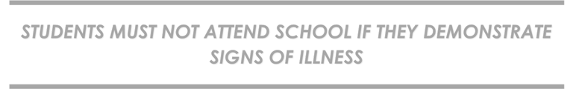

STUDENTS MUST NOT ATTEND SCHOOL IF THEY DEMONSTRATE SIGNS OF ILLNESS

