Nelson PAC Meeting Minutes September 29, 2022

Attendees: Guy Hamilton, Allison Russell, Kelly Liew, May Chin, Anna Kim, Maggie Liang, Jennifer Sydor, Kathy, Lianne (Li Hong) Zhen, May Lai, Sheila Wu, Shalon Morrison, Lisheng Wang

- Call meeting to order 7:00 pm

- Adopt the minutes from previous meeting
  - May motions to adopt the minutes
  - Kelly seconds

- Adopt the agenda
  - May motions to adopt the agenda
  - Kelly seconds

- Principal’s Report - Guy Hamilton
  - Follow up from May 2022: waiting to hear back on cost for youth sized t-shirts in 4 colours.
  - Last year, the sound system and light was updated on the stage thanks to the PAC fundraisers
  - Stone benches were also added (this was the fundraiser that started 2 years ago)
  - Last school goals: targeted reading level, self-regulation. They are now in maintenance and new goals will be identified.
  - This year, Nelson started using a new online booking tool to schedule teacher conferences. This Microsoft booking tool seemed to work well for the most part. In-person and virtual meetings were about 50/50.
  - Kindergarten has transitioned to full time and are normalizing.
  - School sport teams are up and running (e.g. Cross Country)

- Treasurer’s Report - Kelly Liew
  - Need to change signing authorities. Need to add a new person as Adrienne Sankey will no longer be signing. Candace Li is our ex-PAC president.
    - Kelly moves to remove Adrienne Sankey from signing authority and add Candace Li.
    - May seconds
    - No one opposed. Motion is passed.
  - There are two accounts: Gaming and General.
  - Gaming Account (grant Nelson receives from the Gaming Commission)
    - We usually receive around $6500 a year.
    - Approved for $6680 this year.
    - Opening balance: $10,363. Total expected expense: $11,360

  - General Account (PAC fundraisers such as Hot Lunch and Popcorn Sale fund this account)
    - Expenses are similar to previous years (e.g. Grade 7 luncheon, teacher consumables).
    - Teacher consumables are used for supplies/prizes/decorations. Increasing per division amount from $100 to $150. Other schools give $200-400.
    - $2500 is set aside for teachers’ wish list which were used for upgrading the sound system or iPads in the past. Guy to get back to PAC with teachers’ input.
  - Deficit of ~$4000 overall.
  - Anna asked about movie license fee if movie night may not happen. Guy asked District if schools can share movie license fee, waiting to hear back. License may be required for usage in the classrooms, not just for movie night.
  - Question about the Family Emergency Fund. This is usually gift cards to grocery stores to be given to families in need around Christmas time.
  - May motions that we approve the budget.
  - Allison seconds.
  - No one opposed. Budget is approved. (Photo of approved budget below.)

- New Business - Allison Russell
  - Popcorn sale grossed $429 (before expenses)
  - Freezie sale grossed $316
  - Pumpkin Patch, Oct 27, secured pumpkins and delivery.
    - May will run this event but need more volunteers.
    - Talk of decorations. Bales of hay, painting a cutout to create a photo opportunity.
    - Decorating contest between divisions? Guy to check and get back to us.
    - Typically hot chocolate is served.
  - Pancake Breakfast
    - Allison emailed Burnaby Firefighters to see if they can cook the pancakes, waiting to hear back
    - Potential dates: Thursday, December 15 or before December 9
  - Hot Lunch
    - Hot dog lunch will start in November
    - Fresh Slice pizza in the future
    - Subway is another possibility
    - It is difficult to find vendors as previously used vendors have folded.
    - Eurico (sp?) can help with pick up of hot lunch items.
  - Grant applications
    - Allison send a link from Best Buy to Guy. Guy will look into it.

- Any one interested in applying for grants?
  - Flipgive hasn’t been successful. Kelly proposed another announcement goes out since reminder hasn’t gone out recently. Kelly will send a blurb to Guy to include in a future newsletter.
  - Jennifer asked about Poinsettias. May said Grade 7 will use that as a fundraiser.
  - Event calendar

    - A parent asked Allison if newsletter can list all events that are happening (such as Cross Country meets).
    - Guy: newsletter doesn’t usually list sport events due to changes and the large number of different types of events. As soon as dates are finalized, forms for various sports are sent home.
    - May asked if school website calendar can be updated more frequently? E.g. pumpkin patch. Guy: Newsletter usually has major dates on the top but will look into updating the online calendar.
    - Remembrance Day assemblies will be held but divided by Primary and Intermediate. Not sure yet if they will be open to parents. But there will be other events open to parents.

Next meeting: Potentially morning of Nov 4

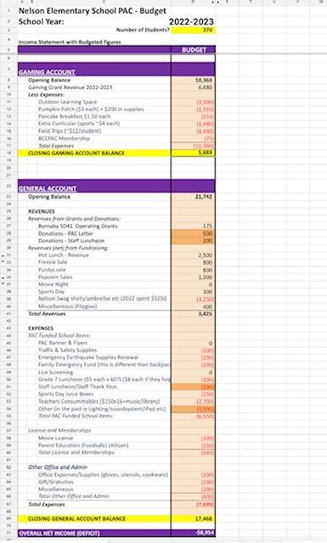
Meeting Adjourned 8:03 pm

